[Department Letterhead]
FOR IMMEDIATE RELEASE
[DATE]
[CONTACT INFORMATION]
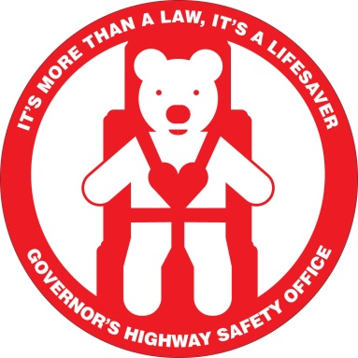
[AGENCY NAME] TAKES PART IN NATIONAL CHILD PASSENGER SAFETY WEEK
[City, State] – [Agency Name] is partnering with the Tennessee Governor’s Highway Safety Office and the National Highway Traffic Safety Administration (NHTSA) to educate parents and caregivers during national Child Passenger Safety week, taking place September 13-19. Motor vehicle crashes are a leading killer of children ages 1 to 13. From 2009 to 2013, an estimated 611,000 children were injured, and 3,335 were killed while riding in cars, pickups, vans, and SUVs.
[Insert information on how your agency is participating: distributing educational material, increasing CPS violation enforcement, holding a checkup event, etc.]
“Using car seats that are age- and size-appropriate is the best way to keep your child safe,” said [Agency Representative]. “Cars seats matter, and having the right car seat installed and used the right way is critical. Too often, parents also move their children to the front seat before they should, which increases the risk of injury and death. The safest place for all kids under 13 is in the back seat of the car,” [he/she] added.
NHTSA recommends keeping children rear-facing as long as possible up to the top height or weight allowed by their particular seats. Once a child outgrows the rear-facing only “infant” car seat, he/she should travel in a rear-facing “convertible” or all-in-one car seat. Once your child outgrows the rear-facing size limits, he or she is ready to travel in a forward-facing car seat with a harness and tether. After outgrowing the forward-facing car seats, children should be placed in booster seats until they’re the right size to use seat belts safely.
“Data collected at car seat check events indicate that 82% of Tennessee children are not properly restrained,” said Governor’s Highway Safety Office Director Kendell Poole. “This could be that they are using the wrong seat for their age or height, that they are not using a seat at all, or that the seat itself was not installed correctly. Certified child passenger safety technicians are located at 128 fitting stations across the state. They are able to inspect your vehicle, seat, and child’s information to see what installation will best fit your needs and keep your little ones the safest.”
For more information on child passenger safety laws and to find a fitting station or child passenger safety technician near you, visit http://tntrafficsafety.org/programs/child-passenger-safety.

